Routed AP
In the default configuration, OpenWrt bridges the wireless network to the LAN of the device. The advantage of bridging is that broadcast traffic from Wireless to LAN and vice versa works without further changes.
In order to separate the wireless network from LAN, a new network with the corresponding DHCP and firewall settings must be created. This document outlines the steps necessary to implement such a setup.
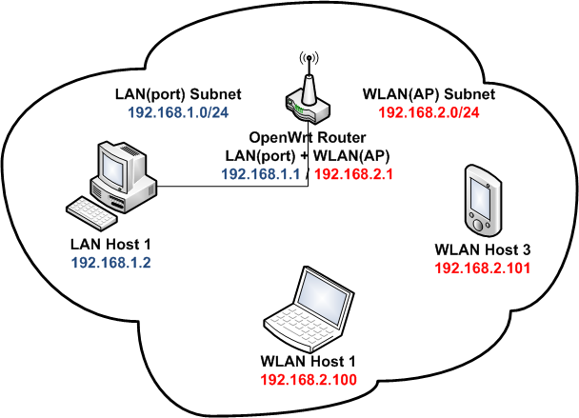

Configuration
The changes below assume an OpenWrt default configuration, the relevant files are:
- /etc/config/network
- /etc/config/wireless
- /etc/config/dhcp
- /etc/config/firewall

Step 1: Define a new network
Edit /etc/config/network and define a new interface section:
config 'interface' 'wifi'
option 'proto' 'static'
option 'ipaddr' '192.168.2.1'
option 'netmask' '255.255.255.0'
Note that no ifname option is set here, it is not required since the wireless network will reference this section later.
Make sure that the chosen IP address is in a different subnet than the one used by the lan interface. For instance, if your lan is in 192.168.1.x space, the wifi must be in the 192.168.2; be aware that the same restrictions may apply regarding your WAN interface

Step 2: Change the existing wireless network
In /etc/config/wireless, locate the existing wifi-iface section and change its network option to point to the newly created interface section.
config 'wifi-iface'
option 'device' 'wl0'
option 'network' 'wifi'
option 'mode' 'ap'
option 'ssid' 'OpenWrt'
option 'encryption' 'none'
In the existing section, network was changed to point to the wifi interface defined in the previous step.
Optionally change the last line for option encryption 'psk2' and add the line option key 'secret key' to enable WPA encryption

Step 3: Define a new DHCP pool (optional)
Since wireless is not bridged to LAN anymore, no DHCP leases are served to wireless clients yet. In order to support DHCP on wireless as well, a new dhcp pool must be defined in /etc/config/dhcp:
config 'dhcp' 'wifi'
option 'interface' 'wifi'
option 'start' '100'
option 'limit' '150'
option 'leasetime' '12h'

Step 4: Adjust firewall settings
By default, traffic originating from the wireless network is not allowed to reach the WAN or the LAN interface. There is also no firewall zone defined for it yet, so only the default policies apply to the wireless network.
Edit /etc/config/firewall and add new zone section covering the wifi interface:
config zone
option name wifi
list network 'wifi'
option input ACCEPT
option output ACCEPT
option forward REJECT
Now that the zone is defined, traffic forwarding control for the wireless network can be implemented. To allow wireless clients to use the WAN interface, add the following forwarding section:
config 'forwarding'
option 'src' 'wifi'
option 'dest' 'wan'
If LAN clients should be able to contact wireless clients, add the following forwarding:
config 'forwarding'
option 'src' 'lan'
option 'dest' 'wifi'
To allow wireless clients to reach the LAN network, add the reversed rule below as well:
config 'forwarding'
option 'src' 'wifi'
option 'dest' 'lan'

Apply changes
- Enable the new wireless network
- ifup wifi
wifi
- Restart the firewall
/etc/init.d/firewall restart
- Restart the DHCP service
/etc/init.d/dnsmasq restart

IPv6 prefix delegation
If you are using IPv6 prefix delegation for subnetting on the LAN side, you might have to adjust the interface parameter ip6assign, which sets the prefix size delegated downstream. For each of lan and wifi in the example, a value of ip6assign must be chosen such that the combined size of these subnets does not exceed the size of the IPv6 prefix available from upstream. Otherwise, one of the assignments would fail. The IPv6 page explains downstream configuration in more detail.

More tweaks
- In some case, you cannot access Internet from “wifi” network clients (though you can do from the router), then you can replace the firewall setting with this https://forum.openwrt.org/viewtopic.php?pid=166701#p166701

